# Israel Stillman

Goran Trajkovski

CS-255 23EW2

December 10, 2023

# CS 255 System Design Document Template

This template lays out all the different sections that you need to complete for Project Two. Each section has guidance to prompt your thinking. You will need to continually reference the interview transcript as you work to make sure that you are addressing your client’s needs. There is no required length for the final document. Instead the goal is to complete each section based on what your client’s needs are. Remove this note when you are finished and replace all bracketed text with the relevant information.

## UML Diagrams

### UML Use Case Diagram

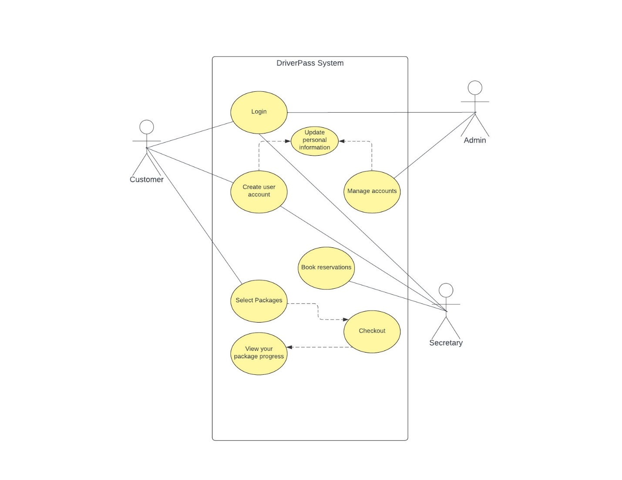

### UML Activity Diagrams

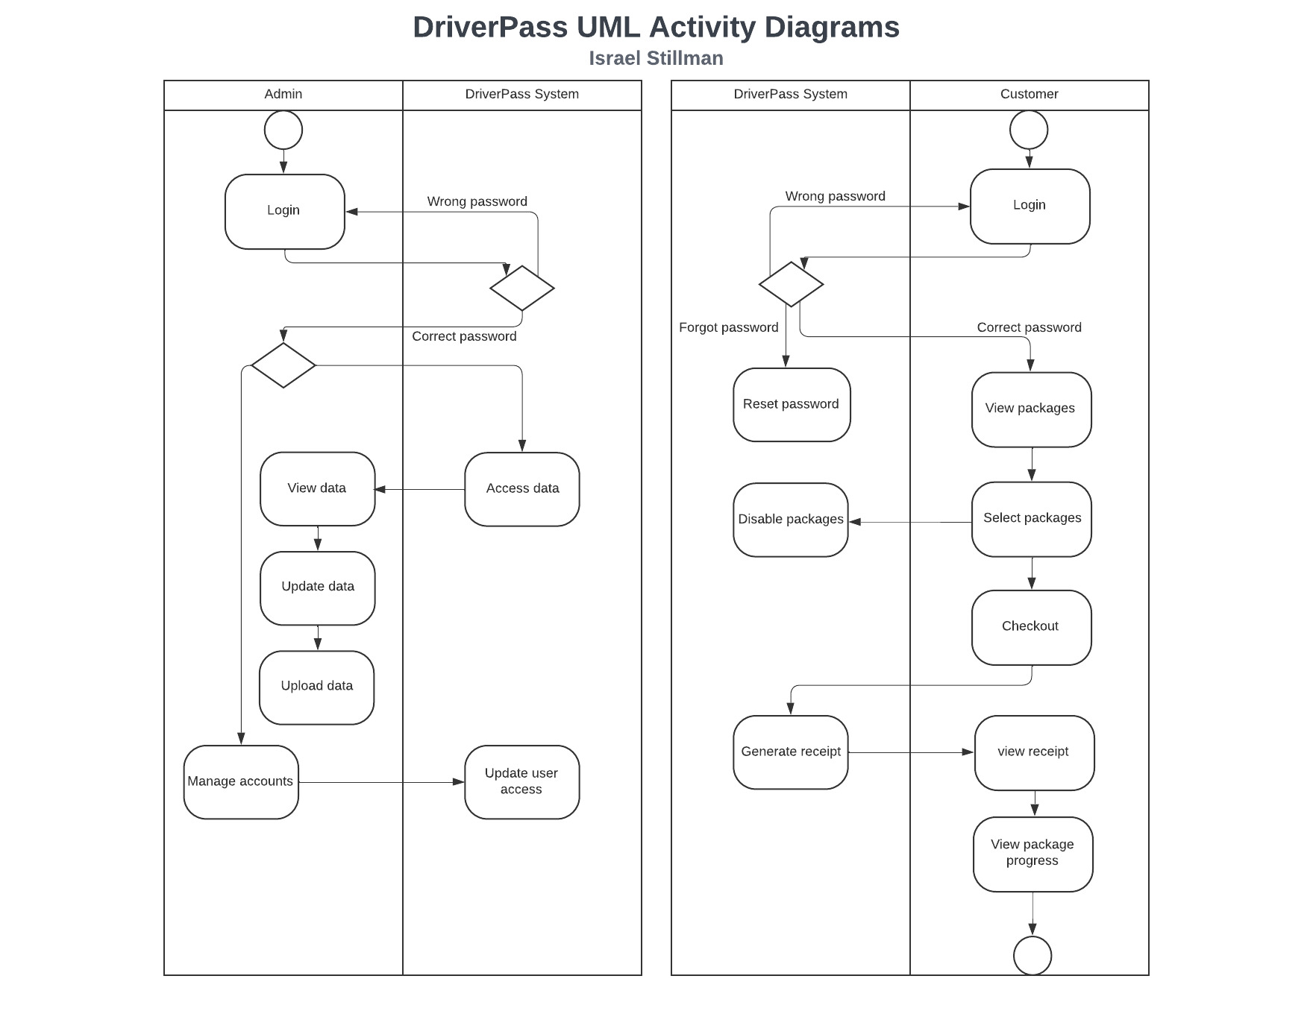

### UML Sequence Diagram

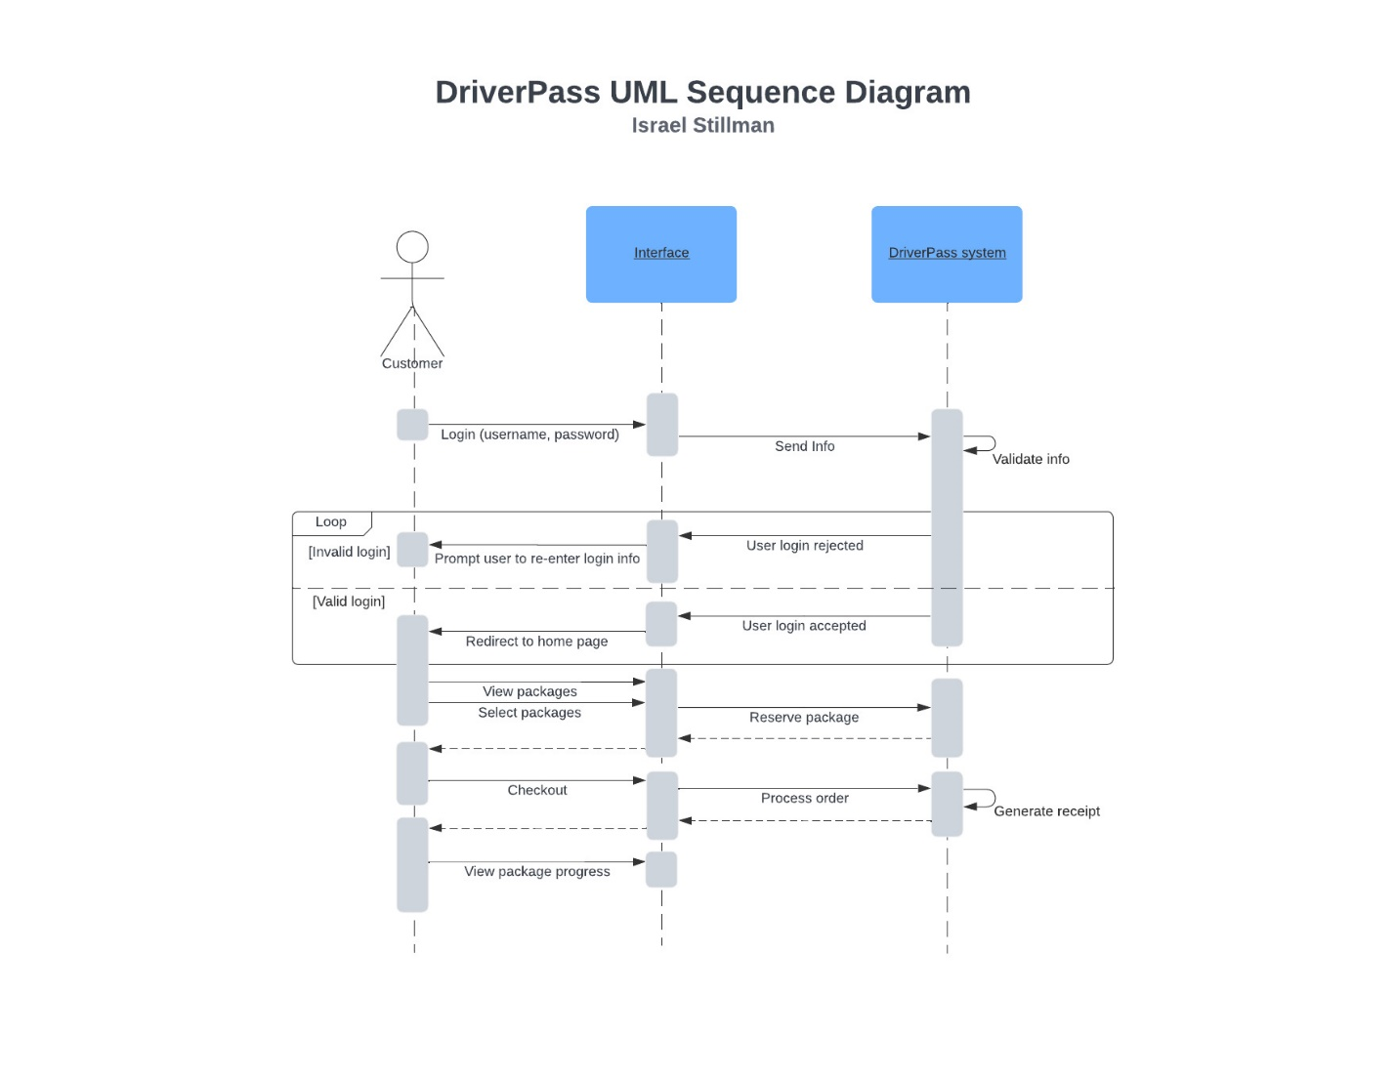

### UML Class Diagram

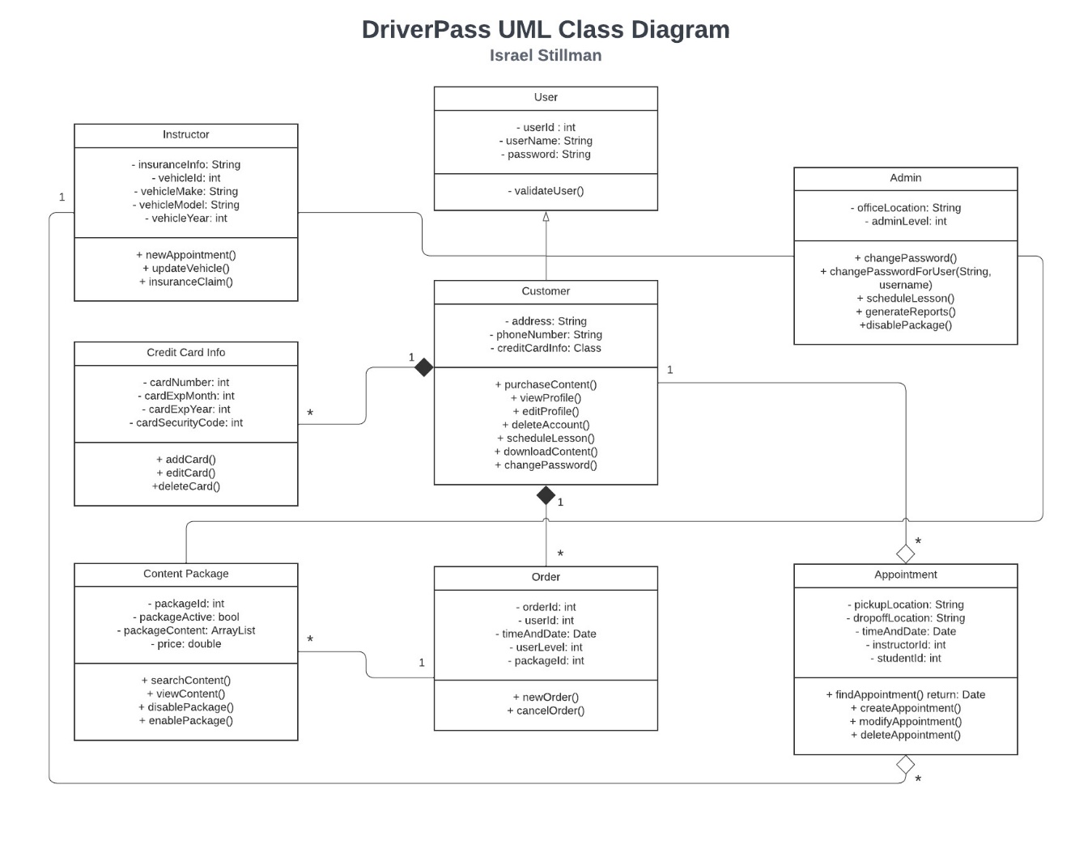

## Technical Requirements

**Hardware Requirements:**

* Cloud-based solutions, scalable infrastructure, and robust server capacity would be necessary.

**Software:**

* Online platform accessible from both computers and mobile devices.
* Reliable internet connectivity for online data access and modifications.
* Cloud-based hosting for the system.
* Database management system (DBMS) for storing and managing user, appointment, and training data.

**Tools:**

* Development tools for building an intuitive user interface with features for registration, scheduling, test progress tracking, and driver notes.
* Development environment for creating use case diagrams, activity diagrams, class diagrams, and implementing business logic.
* Security tools for user authentication, role-based access, and data encryption.
* Connectivity tools to establish communication with the DMV for updates on rules, policies, and sample questions.

**Infrastructure:**

* Robust security measures to prevent unauthorized access, with different user roles and access levels.
* Tracking mechanism to monitor user actions and modifications made within the system.
* Scalable architecture to accommodate future changes and flexibility in modifying service packages.
* Regular backups and system redundancy to prevent data loss.

**System Requirements:**

* **User Roles:**
  + **Owner (Liam):** Access to all functionalities, data management, and modification rights.
  + **IT Officer (Ian):** Full access to manage accounts, reset passwords, and handle system maintenance.
  + **Secretary:** Appointment scheduling and management, basic access to customer data.
  + **Customers:** Access to registration, appointment scheduling, test progress tracking, and course content.
* **Functionality:**
  + Online registration capturing user information, including payment details and appointment preferences.
  + Appointment scheduling for driving lessons with various package options.
  + Comprehensive tracking of appointments, driver assignments, and lesson durations.
  + Test progress tracking and reporting.
  + System connectivity to DMV for updates on regulations and test materials.
* **Security and Compliance:**
  + Robust security measures with different user rights and access levels.
  + Compliance with DMV regulations, including updates on rules, policies, and sample questions.

**Schedule Planning:**

* Phased approach with milestones for requirement collection, design, development, testing, and delivery.
* Timeline divided into specific tasks with designated start and end dates.
* Sequential task completion, ensuring dependencies are managed effectively.
* Regular check-ins with the client to ensure alignment with project objectives.